user guide

ViaFit Fitness Application

Contents

Launching the program. 2

Members - Adding, deleting and editing 2

Add new member. 2

Edit an existing member 3

Adding and removing a member from an event 5

Deleting a member 6

Instructors - Adding, deleting and editing 6

Add new instructor 6

Edit an existing instructor 7

Setting up instructor qualifications 8

Remove an instructor 9

Adding and removing instructors from events 10

Events - Creating, deleting and editing 12

Creating events 12

Editing an existing event 13

Deleting an event 14

Creating and deleting class types for events 14

Using the main screen 15

# Launching the program.

To launch the application, go to the ”ViaFit APP” folder and open the “ViaFit Fitness app.jar” file



The main screen of the program is now displayed like this:  
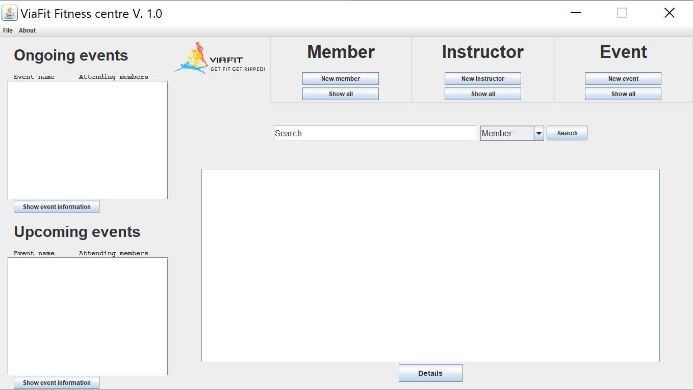

# Members - Adding, deleting and editing

## Add new member.

To add a new member, click the new member button located in the **Top bar**.



The **Member information** window is displayed.

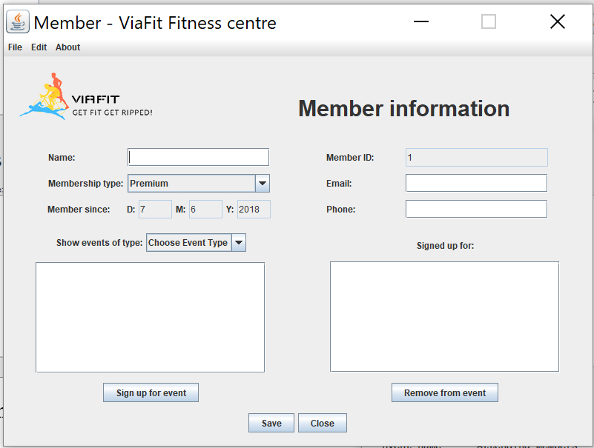

Fill the fields **Name**, **Email** and **Phone** with the information provided by the member and select whether he is a **Premium** or **Standard** member who wish to sign up.  
Click **Save**.

## Edit an existing member

To edit an existing member, search for him by entering parts of his name, parts of his email, parts of his phone number or his member id. You can also click the **Show all** button in the **Top bar**.

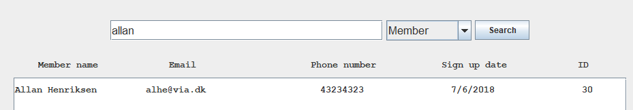

Click the **member** you want to edit and click the **Details** button in the bottom of the screen.



The **Member information** window will pop up showing all information about the selected **member**.

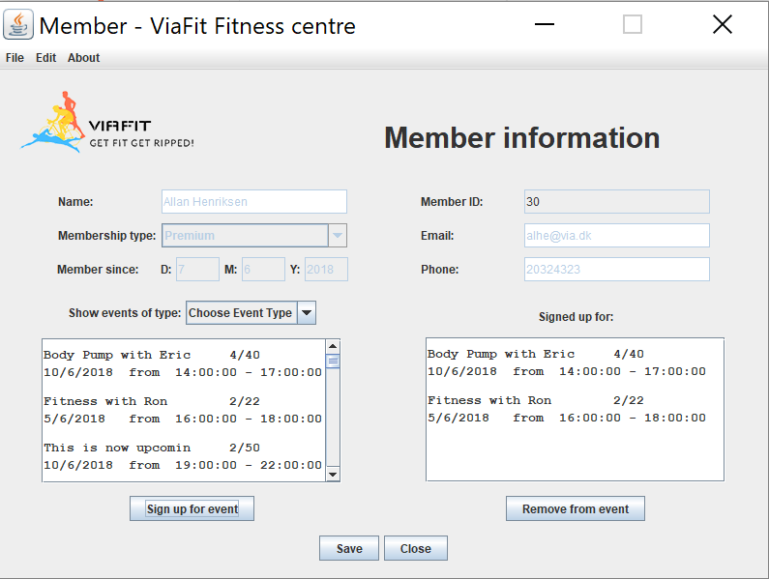

To edit any basic information about the member, name, email, phone number or membership type select the **Edit** menu in the top left corner and click **Edit member.**

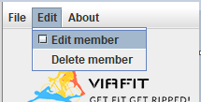

Make your changes and click the **Save** button.

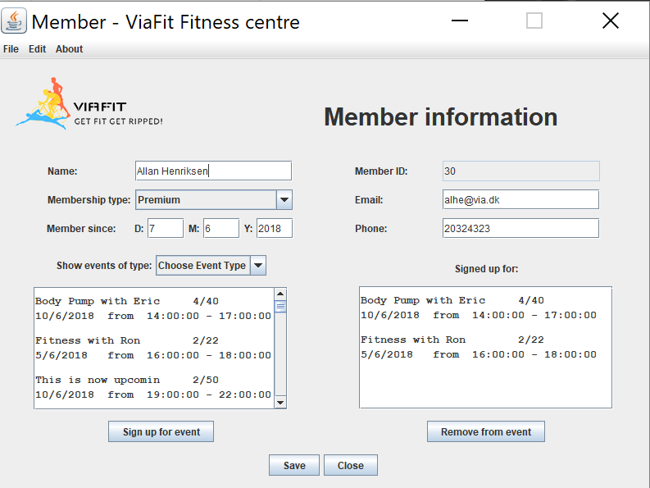

## Adding and removing a member from an event

To sign up a member to an event, search for him by entering parts of his name, parts of his email, parts of his phone number or his member id. You can also click the **Show all** button in the **Top bar** and find the member in the list of members.

Click the **member** you want to edit and click the **Details** button in the bottom of the screen.



The **Member information** window will pop up showing all information about the selected **member**.



All upcoming events will be shown in the left white box. To only who events of a specific type, choose the desired type from the dropdown menu **Show events of type**.

Click the event you wish to sign the member up for and click **Sign up for event**. Likewise, to remove a member from an event, select an event in the white box to the right and click the **Remove from event** button. Click the **Save** button to save your changes.



## Deleting a member

To delete a member, search for him by entering parts of his name, parts of his email, parts of his phone number or his member id. You can also click the **Show all** button in the **Top bar** and find the member in the list of members.

Click the **member** you want to edit and click the **Details** button in the bottom of the screen.



In the **Member information** window, click the **Edit** button in the menu bar and select **Delete member**.

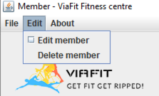

# Instructors - Adding, deleting and editing

## Add new instructor

To add a new instructor, click the **New instructor** button in the **Top bar** in the top of the screen.



The **Instructor information** window is displayed.

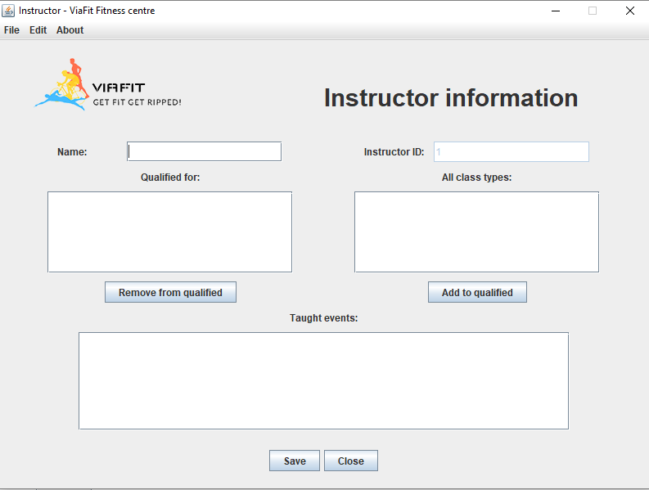

Enter the instructors name in the **name** text field and click the **save** button.

## Edit an existing instructor

To edit an instructor, search for him by entering parts of his name or his instructor ID. You can also click the **Show all** button in the **Top bar** and find the instructor in the list of instructors.

Click the **instructor** you want to edit and click the **Details** button in the bottom. 

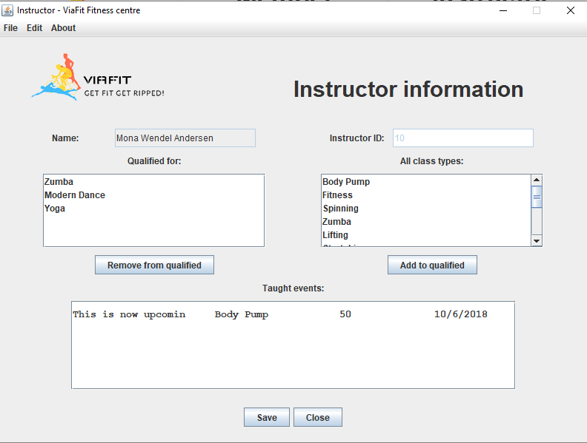

In the **Instructor information** window, select the **Edit** button in the top left menu bar.

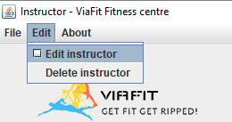

Click the **Edit instructor** button and then you are able you change the name of the instructor.

## Setting up instructor qualifications

To set up the qualifications for an instructor, search for him by entering parts of his name or his instructor ID. You can also click the **Show all** button in the **Top bar** and find the instructor in the list of instructors.

Click the **instructor** you want to edit and click the **Details** button in the bottom. 



The **Instructor information** window is displayed.

Mark the **class type** you want to set qualified for and click the **Add to qualified** button.

Mark the **class type** you want to remove from the qualified list and click the **Remove from qualified** button.

Click the **Save** button to save your changes.

## Remove an instructor

To remove an instructor, search for him by entering parts of his name or his instructor ID. You can also click the **Show all** button in the **Top bar** and find the instructor in the list of instructors.

Click the **instructor** you want to edit and click the **Details** button in the bottom. 



The **Instructor information** window is displayed.

Click the **Edit** button in the top left menu bar and click the **Delete instructor** option.

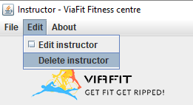

## Adding and removing instructors from events

To add or remove an instructor from an event, search for the event by entering parts of the event name, or parts of the event type. You can also click the **Show all** under the **Event** label in the **top bar**.

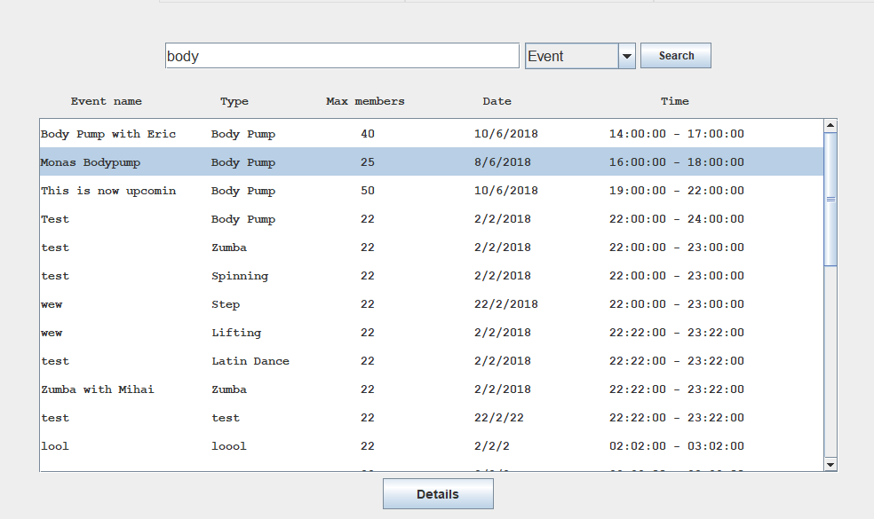

Select the event you wish to assign the instructor to and click the **Details** button.

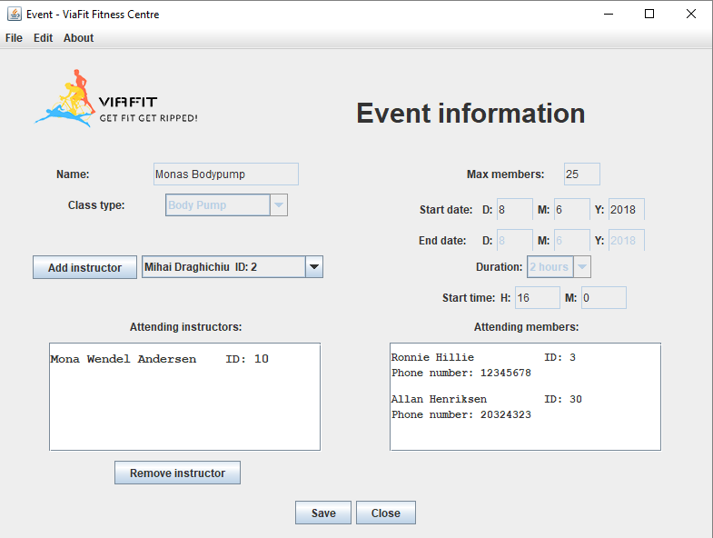

In the **Event information** window, use the **Add instructor** and **Remove instructor** buttons to add or remove the chosen instructor. Please note that only instructors who are **qualified** for the specific class type is shown in the drop-down menu.

# Events - Creating, deleting and editing

## Creating events

To create a new event, click the **New event** button in the **Top bar** of the main screen.

The **Event information** window is displayed.

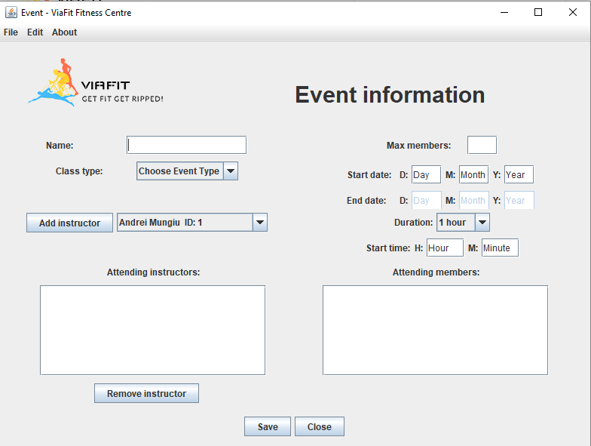

Fill all fields with appropriate information, name, class type, maximum members, start date, duration – how long the event will be and the start time. Click the **save** button to save the event.  
**Note:** Instructors cannot be added or removed before the event is saved.

## Editing an existing event

To edit an existing event, search for the event by entering parts of the event name, or parts of the event type. You can also click the **Show all** under the **Event** label in the **top bar**.



Select the event you wish to assign the instructor to and click the **Details** button.

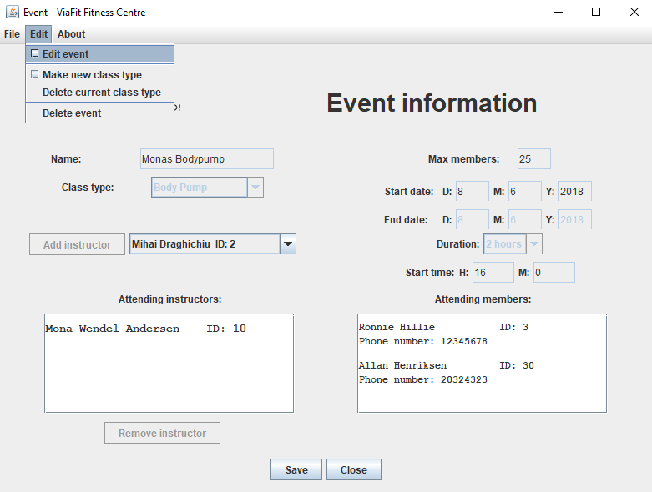

Select the **Edit** button in the top left menu bar and click **Edit event**.

The fields will become editable. Change any information in the window.  
Finish by clicking the **Save** button.

## Deleting an event

To delete an event, search for the event by entering parts of the event name, or parts of the event type.  
You can also click the **Show all** under the **Event** label in the **top bar**.

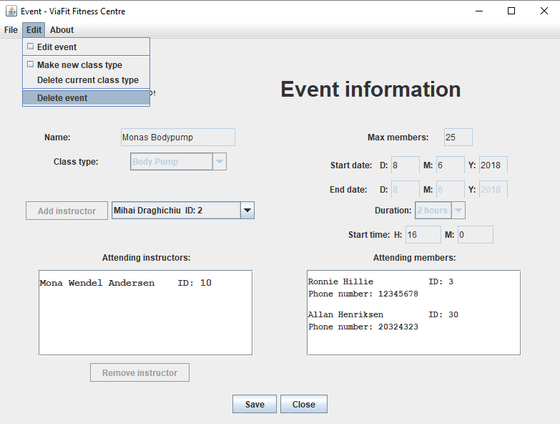

Click the **Edit** button in the top left menu bar and click the **Delete event** button.

## Creating and deleting class types for events

To make a new class type, click the **New event** button in the **Top bar** of the main screen.

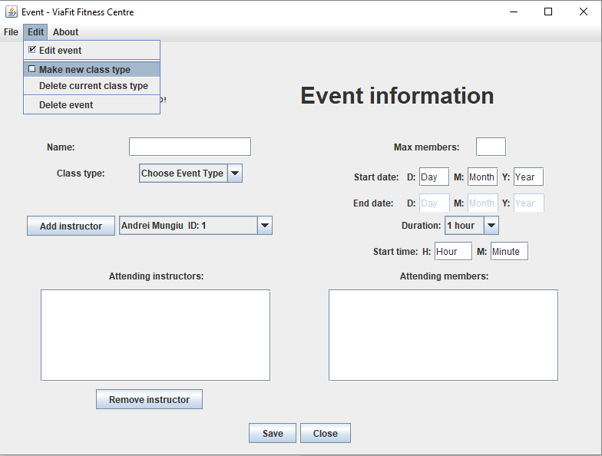Click the **Edit** button in the top left menu bar and click **Make new class type** button.

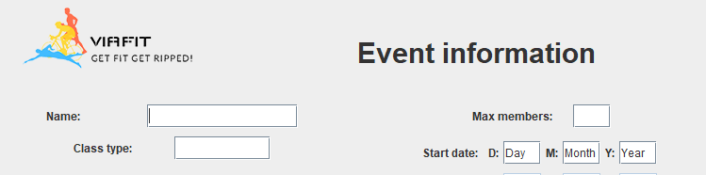  
**Class type** is now a text field, enter the name of the new class type as well as the rest of the event information. Finish by clicking the **Save** button.

To delete a class type, open any **Event information** window.  
Mark the class type that you wish to delete, click the **Edit** button in the top menu bar and click the **Delete current class type**.

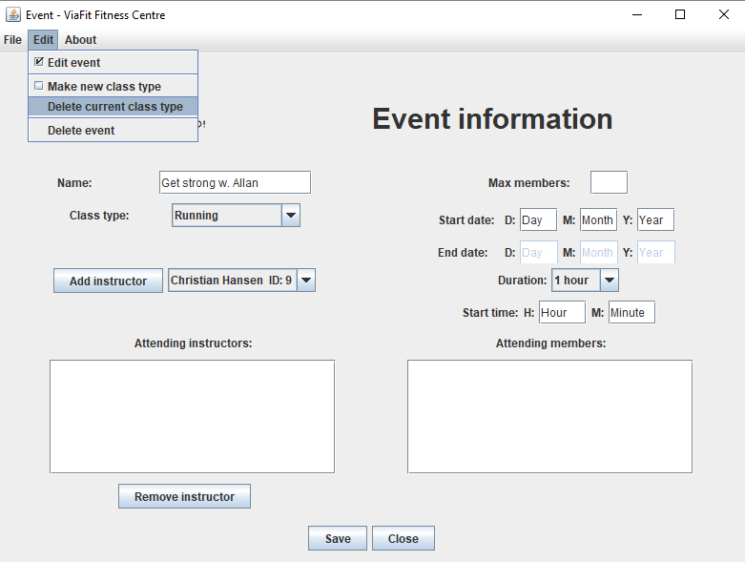

# Using the main screen

The main screen can display lists of all member, instructors and events either by clicking the **Search** button without entering anything in the search field or by clicking the respective **Show all** buttons.

The left side of the screen displays the upcoming and ongoing events, it gives an overview of all events that are currently happening and those that are upcoming sorted by earliest first.

The main screen automatically refreshes itself every 1 minute or upon gaining focus.